Fifth meeting for sprint 2 (Team 77)

## Meeting date | time Date | Time | Meeting location Location

## 16/10/18 4:30 pm-6pm 1.5hr S-block (S502)

|  |  |  |  |  |  |  |  |
| --- | --- | --- | --- | --- | --- | --- | --- |
| |  |  | | --- | --- | | Meeting called by | Keonwoo Lee | | Note taker | Keonwoo Lee | | Timekeeper | Keonwoo Lee | | Attendees  Keonwoo Lee, Dipper Dai, Yiming Pan, Anqi Cui  Non-Attendees  - |

Discussion Conversation

The purpose of having the meeting is to check the progress of week 11’s sprint 2 activities done by each team member and to lay another plan for week12’s sprint 2 activities based on the retrospect.

**Further activities done**

* Story 27: Car description
* Story 15: Browser (Most rented cars)
* The customer can now view different car information with images and details, such as available car seats, series year, engine type and so on
* The company staff can now view most rented cars using charts
* The company staff can now view number of orders per city and per month (unexpected functionalities)
* The charts are available in the “History” menu, not the “Browser” menu as we originally planned

T**o do list for week12’s sprint 2 activities – focused on story 17: Save for later**

|  |  |  |
| --- | --- | --- |
| Action items | Person responsible | Deadline |
| **Topic 1** Create a prototype for the customer accessible page that has such functionality of save for later and verify story is complete (related to task ID T44, T48) | Keonwoo Lee | 19/10/18 |
| **Topic 2** Completing the user manual | Dipper Dai | 26/10/18 |
| **Topic 3** Write code to enable the button ‘save for later’ that sends an email to the customer with the rental car description that the customer likes to order later (related to task ID T46) | Yimming Pan | 19/09/18 |
| **Topic 4** Write test cases (related to task ID T48) | Anqi Cui | 19/09/18 |

**Special notes Type additional notes here**

**-**

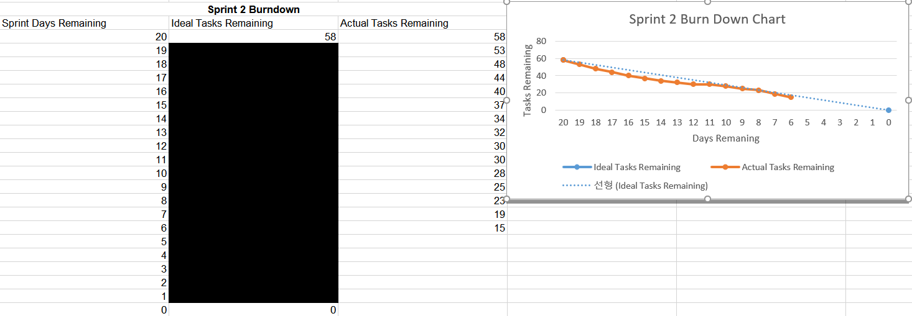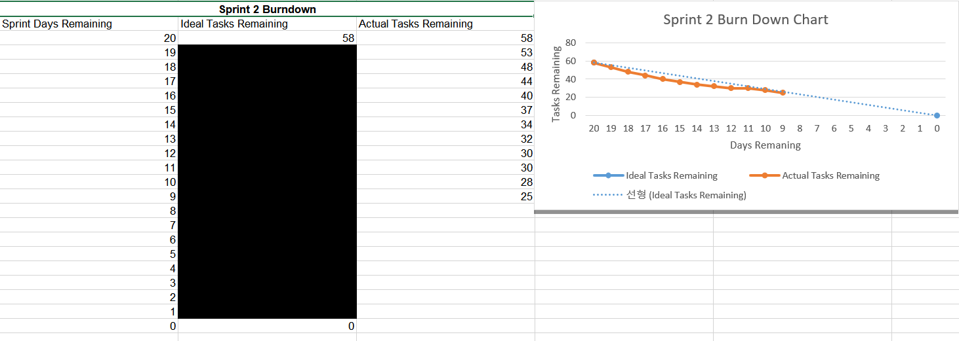**Burndown chart up to date**

**Next meeting:** To be negotiated during the Thursday’s workshop